 |  | Bath Community School
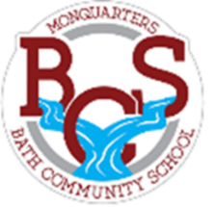 | Monquarter Memo  Volume 3
Phone: 278-6000 Twitter: @BathMonquarters
Website: http://BCS.nbed.nb.ca/
- Water bottles
- Masks (+extra)
- Outdoor clothes (boots & ski pants!)
- Extra hats/mitts
Students are often outside multiple times
a day for Phys. Ed and Recess’.
Please send appropriate clothing with them!
 |  |  | 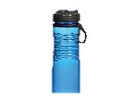  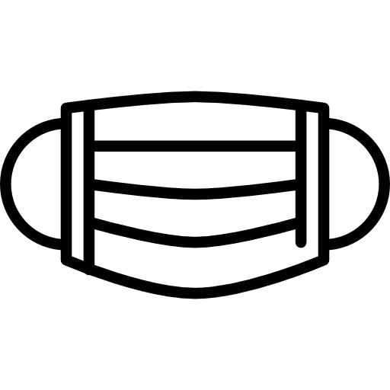  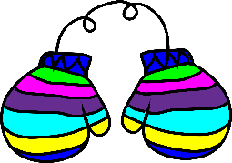  Upcoming Events  Thursday, December 2nd – Parent Teacher evening  If you have not made arrangements for parent teacher yet, please call the school, write a note in the agenda, or email the teacher to do so.  Friday, December 3rd – No school for students  Parent Teacher and Professional Learning for staff.  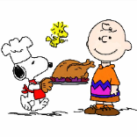  Tuesday, December 16th – Maple syrup pick up  2:30 – 6:00 pm in the BCS gym.  Monday, December 20th – Middle School Bowling trip  Grades 6-8 will travel to Woodstock to bowl and have lunch, 10:30 a.m. – 2:30 p.m.  Tuesday, December 21st – Christmas Colours Day & Christmas Dinner!  Wear as much red and green as you can! Also, Christmas Dinner for all students and staff. A special thank you to the Bath Lion’s Club and all the volunteers who make this possible!  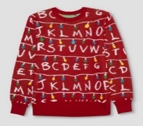  This Photo by Unknown Author is licensed under CC BY-SA-NC  Wednesday, December 22nd - Holiday Duds Day  Wear your favourite ugly sweater or holiday t-shirt.  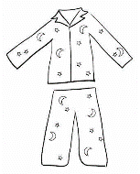  Thursday, December 23rd – PJ Day  Wear comfy clothes, or clean jammies.  Enjoy your Holiday break!  Monday, January 10th – Welcome back! |  | This Photo by Unknown Author is licensed under CC BY-NC

